Why getting Chicago cubs hats online is the right choice to make?
There was a time when looking for the desired products was one of the difficult tasks to look for. With the arrival of the internet, things took a better chance. Now people can easily avail of anything or any service they wish to without giving a second thought. Chicago cubs hats are even available online at a better cost so that one does not have to make a second thought before getting products online.
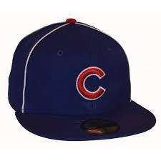
Most of the online companies are trying different ways in which they can add various customers accordingly. One of the best ways is to offer the option of customization. So, one can easily customize the Chicago cubs hats to add a personal touch accordingly.
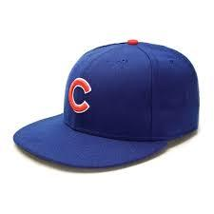
Even there are experts present round the clock who can help in choosing Chicago cubs hats. By getting help from such expert’s one can know the right or the desired product from them according to their requirements. In case you wish to get customized merchandise for yourself, you should know what exactly you want in order to get the best results without any hassle. This way, not only you will look stylish and be the center of attraction among a lot of people, but you will also feel a part of your favorite team as well.
To know more about different and suitable cubs attire or hats online, then one should make sure to give a look at the website carefully https://www.sportsworldchicago.com/Chicago_Cubs_Hats/

